Child Protection in Sport Unit
NSPCC
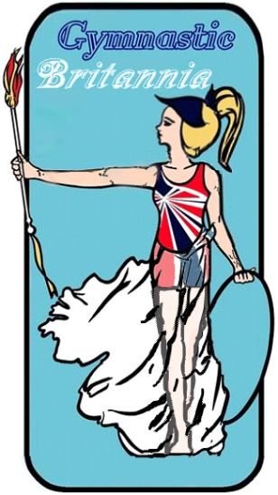

Created by the NSPCC Child Protection in Sport Unit.

Code of conduct for staff and volunteers
Note: Where we refer to ‘parents’ we mean parents and carers inclusively. The term ‘children’ or ‘child’ describes any person under the age of 18.

As a member of staff or a volunteer at our club or activity, we’d like you to:
implement our safeguarding policy and procedures
report any concerns about or allegations of abuse or poor practice to our welfare officer listen to any concerns that parents or young people might have
consider your behaviour — do not engage in any behaviour that constitutes any form of abuse
respect your position of trust and maintain appropriate boundaries and relationships with young people. Engaging in sexual behaviour with any child under the age of 16 is illegal
keep any coaching and safeguarding training up to date
keep children in your sessions safe by supervising appropriately, using safe methods and techniques and by putting children’s safety first
make sure you’ve got appropriate staffing ratios of adult to participant before the session begins
ensure equipment is fit for purpose, safe to use and accessible
respect children’s trust and rights whilst being honest and open with them
champion everyone’s right to take part and celebrate difference in our club or by not discriminating against anyone, regardless of gender, race, sexual orientation or ability
stop play if an injury happens, administer minor first aid and call for help when necessary
use constructive and positive methods of developing children’s skills, without humiliating or harming them
behave appropriately online in accordance with our online safety and acceptable use policy challenge and address instances of poor, negative, aggressive or bullying behaviour
amongst young people
lead by example when it comes to good sportsmanship, positive behaviour and commitment to the sport
develop positive relationships with parents and catch up with them regularly about their child’s development
make our club a friendly and welcoming place to be

Sample code of conduct for staff and volunteers Child Protection in Sport Unit

As a member of our staff, we understand you have the right to:

NSPCC

y’ enjoy the time you spend with us and be supported in your role
be informed of our safeguarding and reporting procedures and what you need to do if something isn’t right
have access to ongoing training in all aspects of your role be listened to
be involved and contribute towards decisions within the club or activity be respected and treated fairly by us and our governing body
feel welcomed, valued and not judged based on your race, gender, sexuality or ability
be protected from physical or emotional abuse from children or parents and be supported to resolve conflicts

We expect all of our staff and volunteers to follow the behaviours and requests set out in this code. If any staff member or volunteer behaves in a way which contradicts any of the points set out above, we’ll address the problem straight away and aim to resolve the issue.

Continued issues and repeated breaches of this code may result in us taking disciplinary action against you with the involvement of governing bodies and ultimately your dismissal from the organisation.

- Signature of staff member *
" or volunteer: t

, Print name of staff
“ member or volunteer: ,

Signature of line manager: «

. Print name of line •
manager: .

Date:

